Tiny College Database
Design & Implementation
Student: Iffa Zainab | Reg #: 2024-CE-90

- Introduction:
This assignment is about designing and implementing a database for Tiny College. The task involves identifying the right entities and relationships, writing a DDL script to create the database in MySQL and generating the ERD through MySQL Workbench's Reverse Engineer feature.

- Entity Design:
The database covers 9 entities i.e. Professor, School, Department, Course, Class, Student, Enroll, Building and Room. Each has its own attributes and is connected to others through foreign key relationships.

Table | Primary Key | Key Attributes
PROFESSOR | PROF_NUM | PROF_RANK, PROF_LNAME, PROF_FNAME, PROF_EMAIL, DEPT_CODE (FK)
SCHOOL | SCHOOL_CODE | SCHOOL_NAME, PROF_NUM (FK = dean)
DEPARTMENT | DEPT_CODE | DEPT_NAME, SCHOOL_CODE (FK), PROF_NUM (FK = chair)
COURSE | CRS_CODE | CRS_TITLE, CRS_CREDIT, DEPT_CODE (FK)
CLASS | CLASS_CODE | CLASS_SECTION, CLASS_TIME, CRS_CODE (FK), PROF_NUM (FK), ROOM_CODE (FK)
STUDENT | STU_NUM | STU_LNAME, STU_FNAME, STU_EMAIL, DEPT_CODE (FK), PROF_NUM (FK = advisor)
ENROLL | STU_NUM + CLASS_CODE | ENROLL_DATE, ENROLL_GRADE
BUILDING | BLDG_CODE | BLDG_NAME, BLDG_LOCATION
ROOM | ROOM_CODE | ROOM_TYPE, BLDG_CODE (FK)

- ENROLL uses a composite primary key (STU_NUM + CLASS_CODE) since a student can enroll in many classes and a class can have many students.
- PROFESSOR and DEPARTMENT reference each other as a professor belongs to a department and a department is chaired by a professor. This was handled using ALTER TABLE after both tables were created.
- STUDENT has two foreign keys to PROFESSOR , one for the department (DEPT_CODE) and one for the assigned advisor (PROF_NUM).

- Entity Relationship Diagram (ERD):
I generated the ERD below automatically by MySQL Workbench using the Reverse Engineer feature after executing the DDL script. It shows all 9 tables and the foreign key relationships between them.

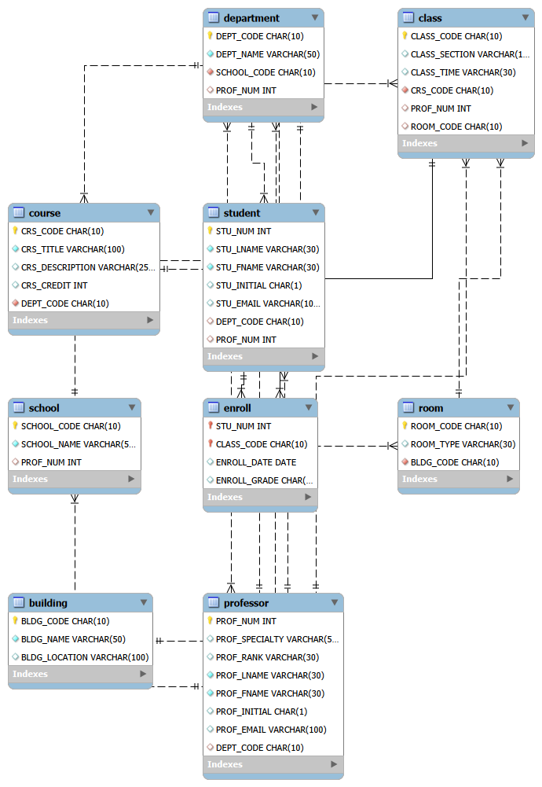
Fig: Tiny College ERD generated through MySQL Workbench
Key relationships visible in the ERD:
- SCHOOL—DEPARTMENT: one school operates many departments
- DEPARTMENT—COURSE: one department offers many courses
- COURSE—CLASS: one course generates many class sections
- PROFESSOR—CLASS: one professor teaches many classes
- BUILDING—ROOM—CLASS: a building contains rooms, and rooms are used for classes
- STUDENT—ENROLL—CLASS: students enroll in classes through the ENROLL bridge table

- Implementation in MySQL Workbench:

Step 1 : Open a Query Tab and Paste the Script
I opened MySQL Workbench and connected to the local server. Then opened a new query tab and pasted the DDL script.

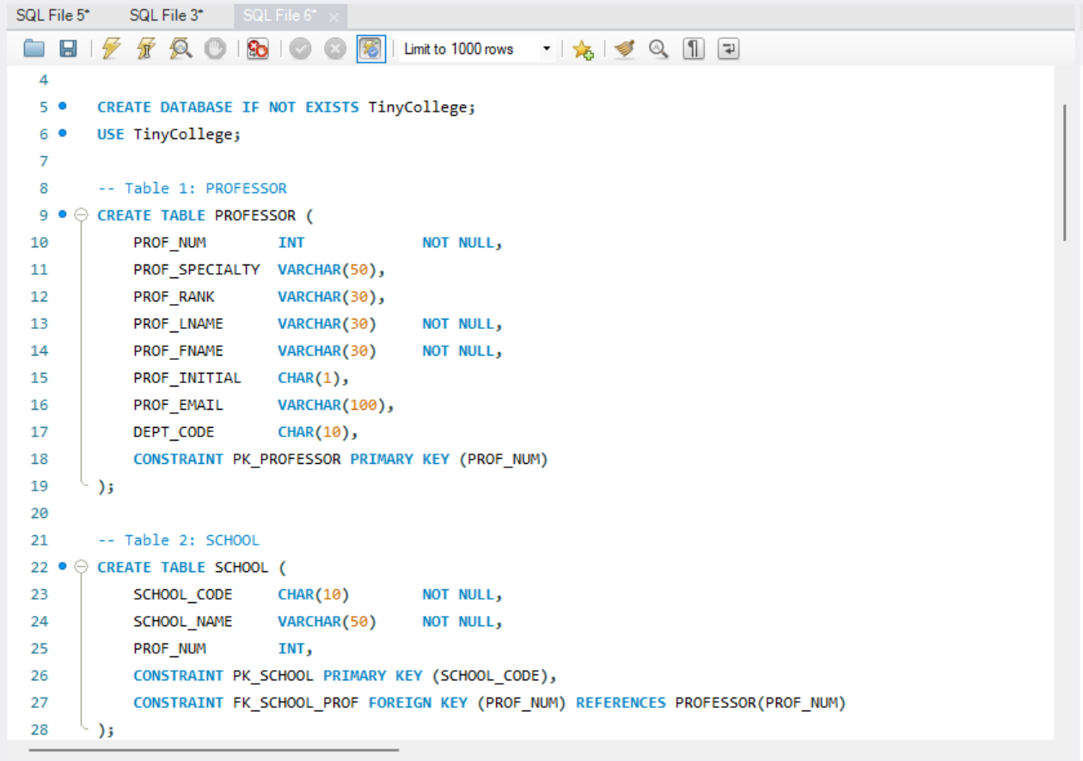
Fig: DDL script in the MySQL Workbench query editor

Step 2 : Execution
All statements executed without errors. The output panel at the bottom showed green checkmarks for every statement confirming the database and all 9 tables were created successfully.
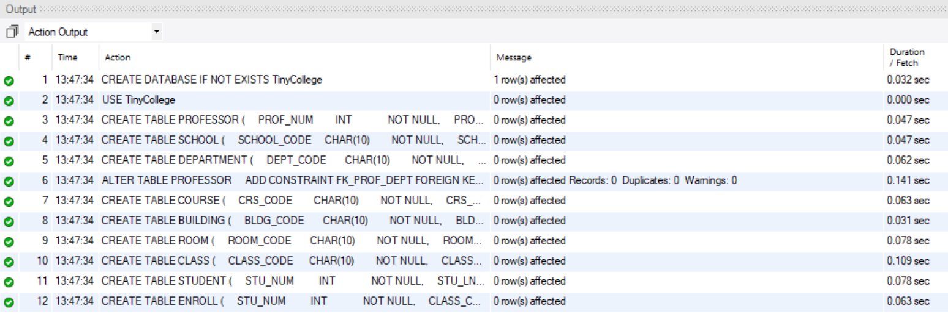
Fig: Successful execution, all 9 tables created with no errors

Step 3 : Verifying the Schema
Refreshed the Schemas panel on the left side was and TinyCollege appeared with all 9 tables listed.

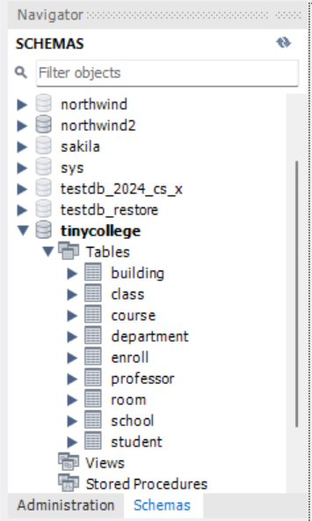
Fig: TinyCollege schema visible in the Schemas panel

- DDL Script:
The complete script used to create the TinyCollege database is given below.
CREATE DATABASE IF NOT EXISTS TinyCollege;
USE TinyCollege;

-- Table 1: PROFESSOR
CREATE TABLE PROFESSOR (
PROF_NUM INT NOT NULL,
PROF_SPECIALTY VARCHAR(50),
PROF_RANK VARCHAR(30),
PROF_LNAME VARCHAR(30) NOT NULL,
PROF_FNAME VARCHAR(30) NOT NULL,
PROF_INITIAL CHAR(1),
PROF_EMAIL VARCHAR(100),
DEPT_CODE CHAR(10),
CONSTRAINT PK_PROFESSOR PRIMARY KEY (PROF_NUM)
);

-- Table 2: SCHOOL
CREATE TABLE SCHOOL (
SCHOOL_CODE CHAR(10) NOT NULL,
SCHOOL_NAME VARCHAR(50) NOT NULL,
PROF_NUM INT,
CONSTRAINT PK_SCHOOL PRIMARY KEY (SCHOOL_CODE),
CONSTRAINT FK_SCHOOL_PROF FOREIGN KEY (PROF_NUM) REFERENCES PROFESSOR(PROF_NUM)
);

-- Table 3: DEPARTMENT
CREATE TABLE DEPARTMENT (
DEPT_CODE CHAR(10) NOT NULL,
DEPT_NAME VARCHAR(50) NOT NULL,
SCHOOL_CODE CHAR(10) NOT NULL,
PROF_NUM INT,
CONSTRAINT PK_DEPARTMENT PRIMARY KEY (DEPT_CODE),
CONSTRAINT FK_DEPT_SCHOOL FOREIGN KEY (SCHOOL_CODE) REFERENCES SCHOOL(SCHOOL_CODE),
CONSTRAINT FK_DEPT_PROF FOREIGN KEY (PROF_NUM) REFERENCES PROFESSOR(PROF_NUM)
);

ALTER TABLE PROFESSOR
ADD CONSTRAINT FK_PROF_DEPT FOREIGN KEY (DEPT_CODE) REFERENCES DEPARTMENT(DEPT_CODE);

-- Table 4: COURSE
CREATE TABLE COURSE (
CRS_CODE CHAR(10) NOT NULL,
CRS_TITLE VARCHAR(100) NOT NULL,
CRS_DESCRIPTION VARCHAR(255),
CRS_CREDIT INT,
DEPT_CODE CHAR(10) NOT NULL,
CONSTRAINT PK_COURSE PRIMARY KEY (CRS_CODE),
CONSTRAINT FK_COURSE_DEPT FOREIGN KEY (DEPT_CODE) REFERENCES DEPARTMENT(DEPT_CODE)
);

-- Table 5: BUILDING
CREATE TABLE BUILDING (
BLDG_CODE CHAR(10) NOT NULL,
BLDG_NAME VARCHAR(50) NOT NULL,
BLDG_LOCATION VARCHAR(100),
CONSTRAINT PK_BUILDING PRIMARY KEY (BLDG_CODE)
);

-- Table 6: ROOM
CREATE TABLE ROOM (
ROOM_CODE CHAR(10) NOT NULL,
ROOM_TYPE VARCHAR(30),
BLDG_CODE CHAR(10) NOT NULL,
CONSTRAINT PK_ROOM PRIMARY KEY (ROOM_CODE),
CONSTRAINT FK_ROOM_BLDG FOREIGN KEY (BLDG_CODE) REFERENCES BUILDING(BLDG_CODE)
);

-- Table 7: CLASS
CREATE TABLE CLASS (
CLASS_CODE CHAR(10) NOT NULL,
CLASS_SECTION VARCHAR(10),
CLASS_TIME VARCHAR(30),
CRS_CODE CHAR(10) NOT NULL,
PROF_NUM INT,
ROOM_CODE CHAR(10),
CONSTRAINT PK_CLASS PRIMARY KEY (CLASS_CODE),
CONSTRAINT FK_CLASS_COURSE FOREIGN KEY (CRS_CODE) REFERENCES COURSE(CRS_CODE),
CONSTRAINT FK_CLASS_PROF FOREIGN KEY (PROF_NUM) REFERENCES PROFESSOR(PROF_NUM),
CONSTRAINT FK_CLASS_ROOM FOREIGN KEY (ROOM_CODE) REFERENCES ROOM(ROOM_CODE)
);

-- Table 8: STUDENT
CREATE TABLE STUDENT (
STU_NUM INT NOT NULL,
STU_LNAME VARCHAR(30) NOT NULL,
STU_FNAME VARCHAR(30) NOT NULL,
STU_INITIAL CHAR(1),
STU_EMAIL VARCHAR(100),
DEPT_CODE CHAR(10),
PROF_NUM INT,
CONSTRAINT PK_STUDENT PRIMARY KEY (STU_NUM),
CONSTRAINT FK_STU_DEPT FOREIGN KEY (DEPT_CODE) REFERENCES DEPARTMENT(DEPT_CODE),
CONSTRAINT FK_STU_PROF FOREIGN KEY (PROF_NUM) REFERENCES PROFESSOR(PROF_NUM)
);

-- Table 9: ENROLL
CREATE TABLE ENROLL (
STU_NUM INT NOT NULL,
CLASS_CODE CHAR(10) NOT NULL,
ENROLL_DATE DATE,
ENROLL_GRADE CHAR(2),
CONSTRAINT PK_ENROLL PRIMARY KEY (STU_NUM, CLASS_CODE),
CONSTRAINT FK_ENROLL_STU FOREIGN KEY (STU_NUM) REFERENCES STUDENT(STU_NUM),
CONSTRAINT FK_ENROLL_CLASS FOREIGN KEY (CLASS_CODE) REFERENCES CLASS(CLASS_CODE)
);

- Conclusion:
This lab covered the complete process of turning a real-world scenario into a working relational database. The Tiny College case study was analyzed, 9 entities were identified, and the schema was implemented in MySQL with all necessary primary and foreign key constraints.

